Biotox Gold Swipe Packet 2

(affiliates@biotoxnutrition.com)

Tips:

- Send to the VSL page for maximum conversions
- Send the same email to all unopens 24 hours after your previous email. Use the provided second subject line for this.

VSL Page:

https://hop.clickbank.net/?affiliate=XXXX&vendor=npounder95

Email 1

Subject

First send: He lost HOW much!? Only doing this 30-second morning ritual 😱

Unopens: Breaking: Newly discovered “30-Second Scorch Ritual” melts away belly fat bulging over your waistband (video tutorial)

Body

Embarrassed by that extra fat hanging over your waistband?

If so, you’re not alone…

But….

You’re about to see something amazing. There’s actually a newly discovered unusual “30 Second Scorch Routine” everyday men and women just like you are using to melt away stubborn belly fat, detoxify their body, and skyrocket energy.

In fact, over 200,000 people are using this “30 Second Scorch Routine” in the mornings to get some crazy results (like Richard) who lost over 100lbs, yes 100, using this exact same ritual:

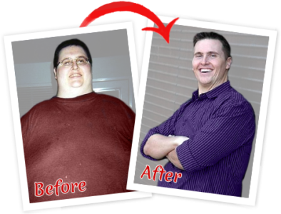

Or Sandra, who had been struggling to shake off the baby weight after her second child, lost over 54lbs!

Or even Janice, who had been battling with her weight for years, started doing this simple morning ritual and burned away 78lbs

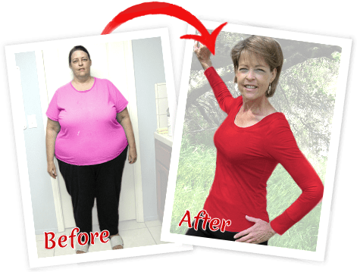

And the list of individuals just like YOU goes on and on!

I’m sure you’ve tried every diet and gimmick out there…

Hoping to find the one secret to finally look amazing…

And stop getting those judgmental looks about your weight…

But you just keep giving up because nothing seems to work.

If that sounds familiar… You’re lucky because the general public has never seen this “30 Second Scorch Routine” before.

So, that means you’re about to get an exclusive never before seen look at this groundbreaking discovery!

⇒ Give Yourself One More Chance To Melt Extra Fat With This Unusual “30 Second Scorch Routine” (full video explanation)

Take notes on this video because it shatters everything you think you know about fat loss.

See you on the inside,
(Your NAME)

Email 2

Subject

First send: No, Wait! Don’t throw out those old jeans yet! Here’s how fit in them again with a weird “exotic fruit trick”...

Unopens: What your one “hot” friend will never tell you about losing weight (weird exotic “fat burning” fruit trick enclosed)

Body

Most women actually keep their old jeans in the back of their closet… Hoping they’ll be skinny enough to fit in them again.

If you still do that too, don’t feel bad… Because there’s actually one undiscovered “Exotic Fruit Trick” that helps you melt off the extra fat (over 200,000 people already use this).

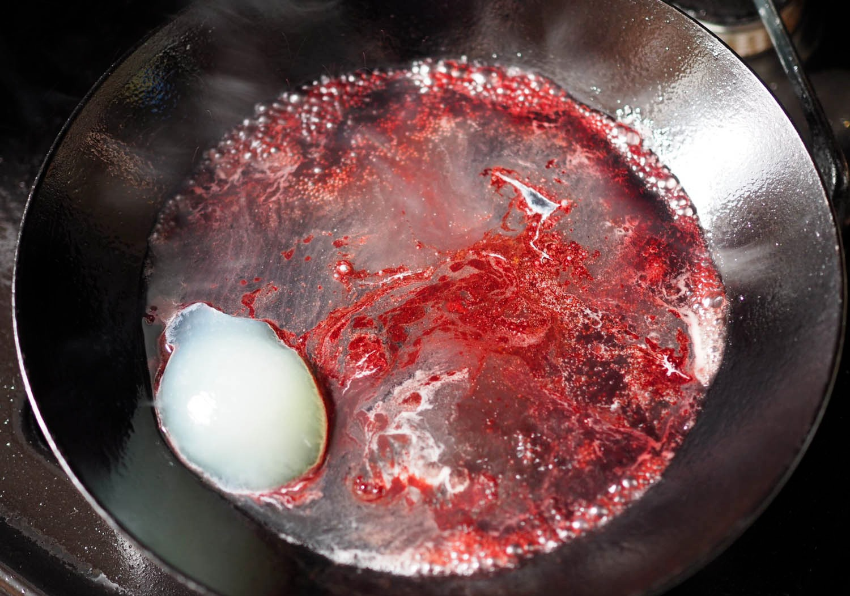

Most people don’t trust the fitness industry because they’ve tried every workout plan, diet, and fat burning supplement out there…

Wishing they could turn heads like that one “hot” friend who has it so easy… And hoping they can finally feel confident looking in the mirror…

Only to give up time and time again.

So I’m not sure if this “Exotic Fruit Trick” is what you’re looking for, but you might as well check it out:

⇒ This Weird “Exotic Fruit Trick” Is Melting Fat & Skyrocketing Energy For Over 200,000 People (see the video demonstration here)

Remember, you deserve to look your best.

-NAME

