Biotox Gold Swipe Packet 1

(affiliates@biotoxnutrition.com)

Tips:

- Send to the VSL page for maximum conversions
- Send the same email to all unopens 24 hours after your previous email. Use the provided second subject line for this.

VSL Page:

https://hop.clickbank.net/?affiliate=XXXX&vendor=npounder95

Email 1

Subject

First Send: [Exposed] Top doctor reveals the #1 fat burning fruit you should be taking right now…

Unopened: 😲 You won’t believe these results, shocking new revelation turns weight loss industry on its head

Body

(First name), You have to see this...

A recent shocking study done by a group of prominent scientists in Nevada revealed ONE exotic fruit that can obliterate even the deepest stored body fat in your body

Plus, multiple studies have shown that it suppresses intense food cravings, lowers cholesterol and blood sugar… and flick a “master switch” that STOPS fat production.

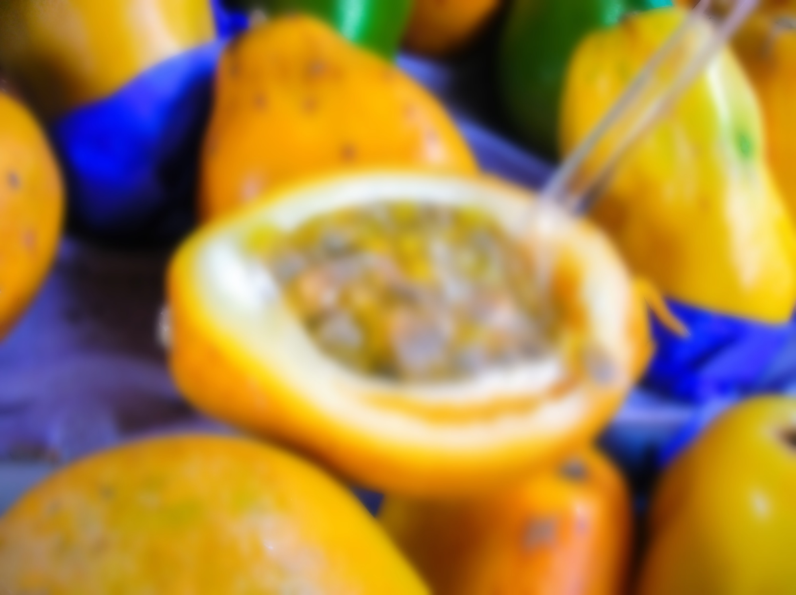

Try to guess what this exotic fruit is:

A. Durian
B. Cherimoya
C. Garcinia
D. Starfruit
E. Mangosteen

Even if you’re a “health nut”, I doubt what you think is right. The answer is counter-intuitive.

If you guess right, you could easily burn off stubborn body fat — without doing any extra exercise, fad diets, or giving up your favorite foods.

Guess wrong, you could spend the rest of your life all within a body saturated by disgusting, unhealthy body fat.

Click here to see if you’re right and put you’re knowledge to the test

[SIGN OFF]

P.S. Click here to jump straight to the answer.

Email 2

Subject

First send: Do THIS to burn away 2lbs of belly fat overnight

Unopens: Ancient Indonesian herbal recipe crushes food cravings

Body

It’s important that you read this …

An incredible breakthrough was accidentally discovered by a special education teacher from Henderson NV that has now led to over 200,000 women and men all over the world, who all suffered from varying degrees of obesity to burn away belly fat, skyrocket metabolism and boost energy levels!

It is said to be 5x more effective than any exercise and 8x more effective than any diet!

And that’s not the best part? They found its 3x MORE effective than any surgery at eliminating cravings for sugar and starchy foods and it’s completely all natural!

==> Newly Discovered Exotic Fruit Eliminates Food Cravings & Burns Away Fat

YOURNAME

PS. This ugly-looking fat-burning ‘exotic fruit’ looks like this. You can even find it in your backyard!

Email 3

Subject

First send: Recently divorced mother of 2 loses 71lbs with morning “ritual” (before/after pics)

Unopens: She lost 71lbs, now she looks like THIS…

Body

Tonya, a 49 year old mom of 2, was close to giving up…

Her husband had just left her for a younger woman. She was struggling with her weight and her health was getting out of control…

She’d tried everything…

That is, until she found this “odd” 30-second morning ritual and dropped 71lbs in less than 12 weeks!

Carter also used this ritual to lose 34lbs and his snoring vanished!

Deborah, who was scared that her husband didn’t see her the way he used to, lost over 56lbs and now she’s reported her husband can’t keep his hands off of her.

I can’t wait for you to see their incredible transformations yourself…

==> Odd 30-second Morning “Ritual” Helps Mom of 3 Lose 71lbs (See Before/After pics)

YOURNAME

P.S. Is it true you can really burn pounds of stubborn fat away with a simple “morning ritual”? See how, here… and make sure you check out the before & after transformations too. These photos are AMAZING.

